**System Implementation**

**1.1 Complete System implementation:**

The main feature of the system is to perform registration of the student. In this project we use python flask framework, html, CSS, JavaScript, bootstrap. In this project we will register the student, delete the register student, update the register student data and search the record with roll number. The major modules of the web application will be discussed in detail.

So, how user can use our system? there are step-by-step information given bellow.

* + 1. **How system works / User guide:**

Users can know about our website that how it works to perform snap audit. So, it contains step-by-step information to use it.

* + 1. **Register student:**

In this section we will register the student with following information

* Roll no
* Name
* Father name
* Email
* Gender
* Nationality
* Phone

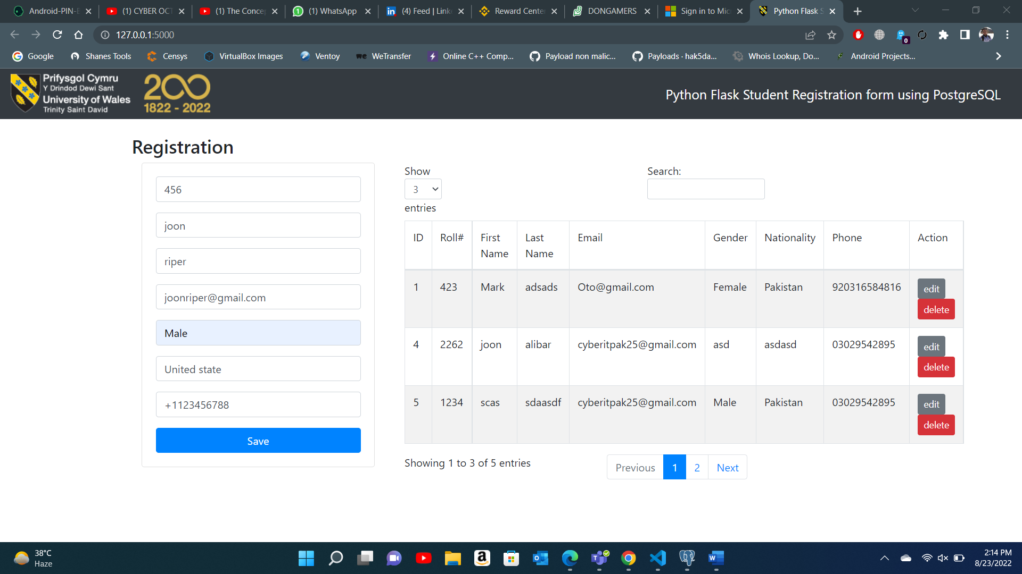

* + 1. **Search and display record:**

In this you will search the record via student roll number and if the student roll is present in data base they will show up in table

Search



Display

* + 1. **Edit/ update the record:**

In this edit section we will able to edit the present record in database first press the edit button which is grey color button then you will go to edit section and update the record then press the update button



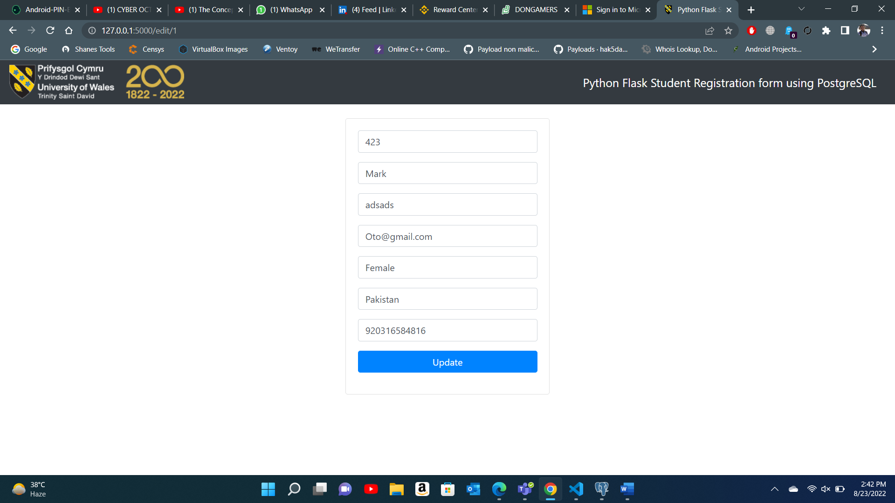



* + 1. **Delete the record:**

If you want to delete the record press the red button front of record you want to delete from database. When you press the delete button popup message show and confirm to delete the record. Record successfully deleted



